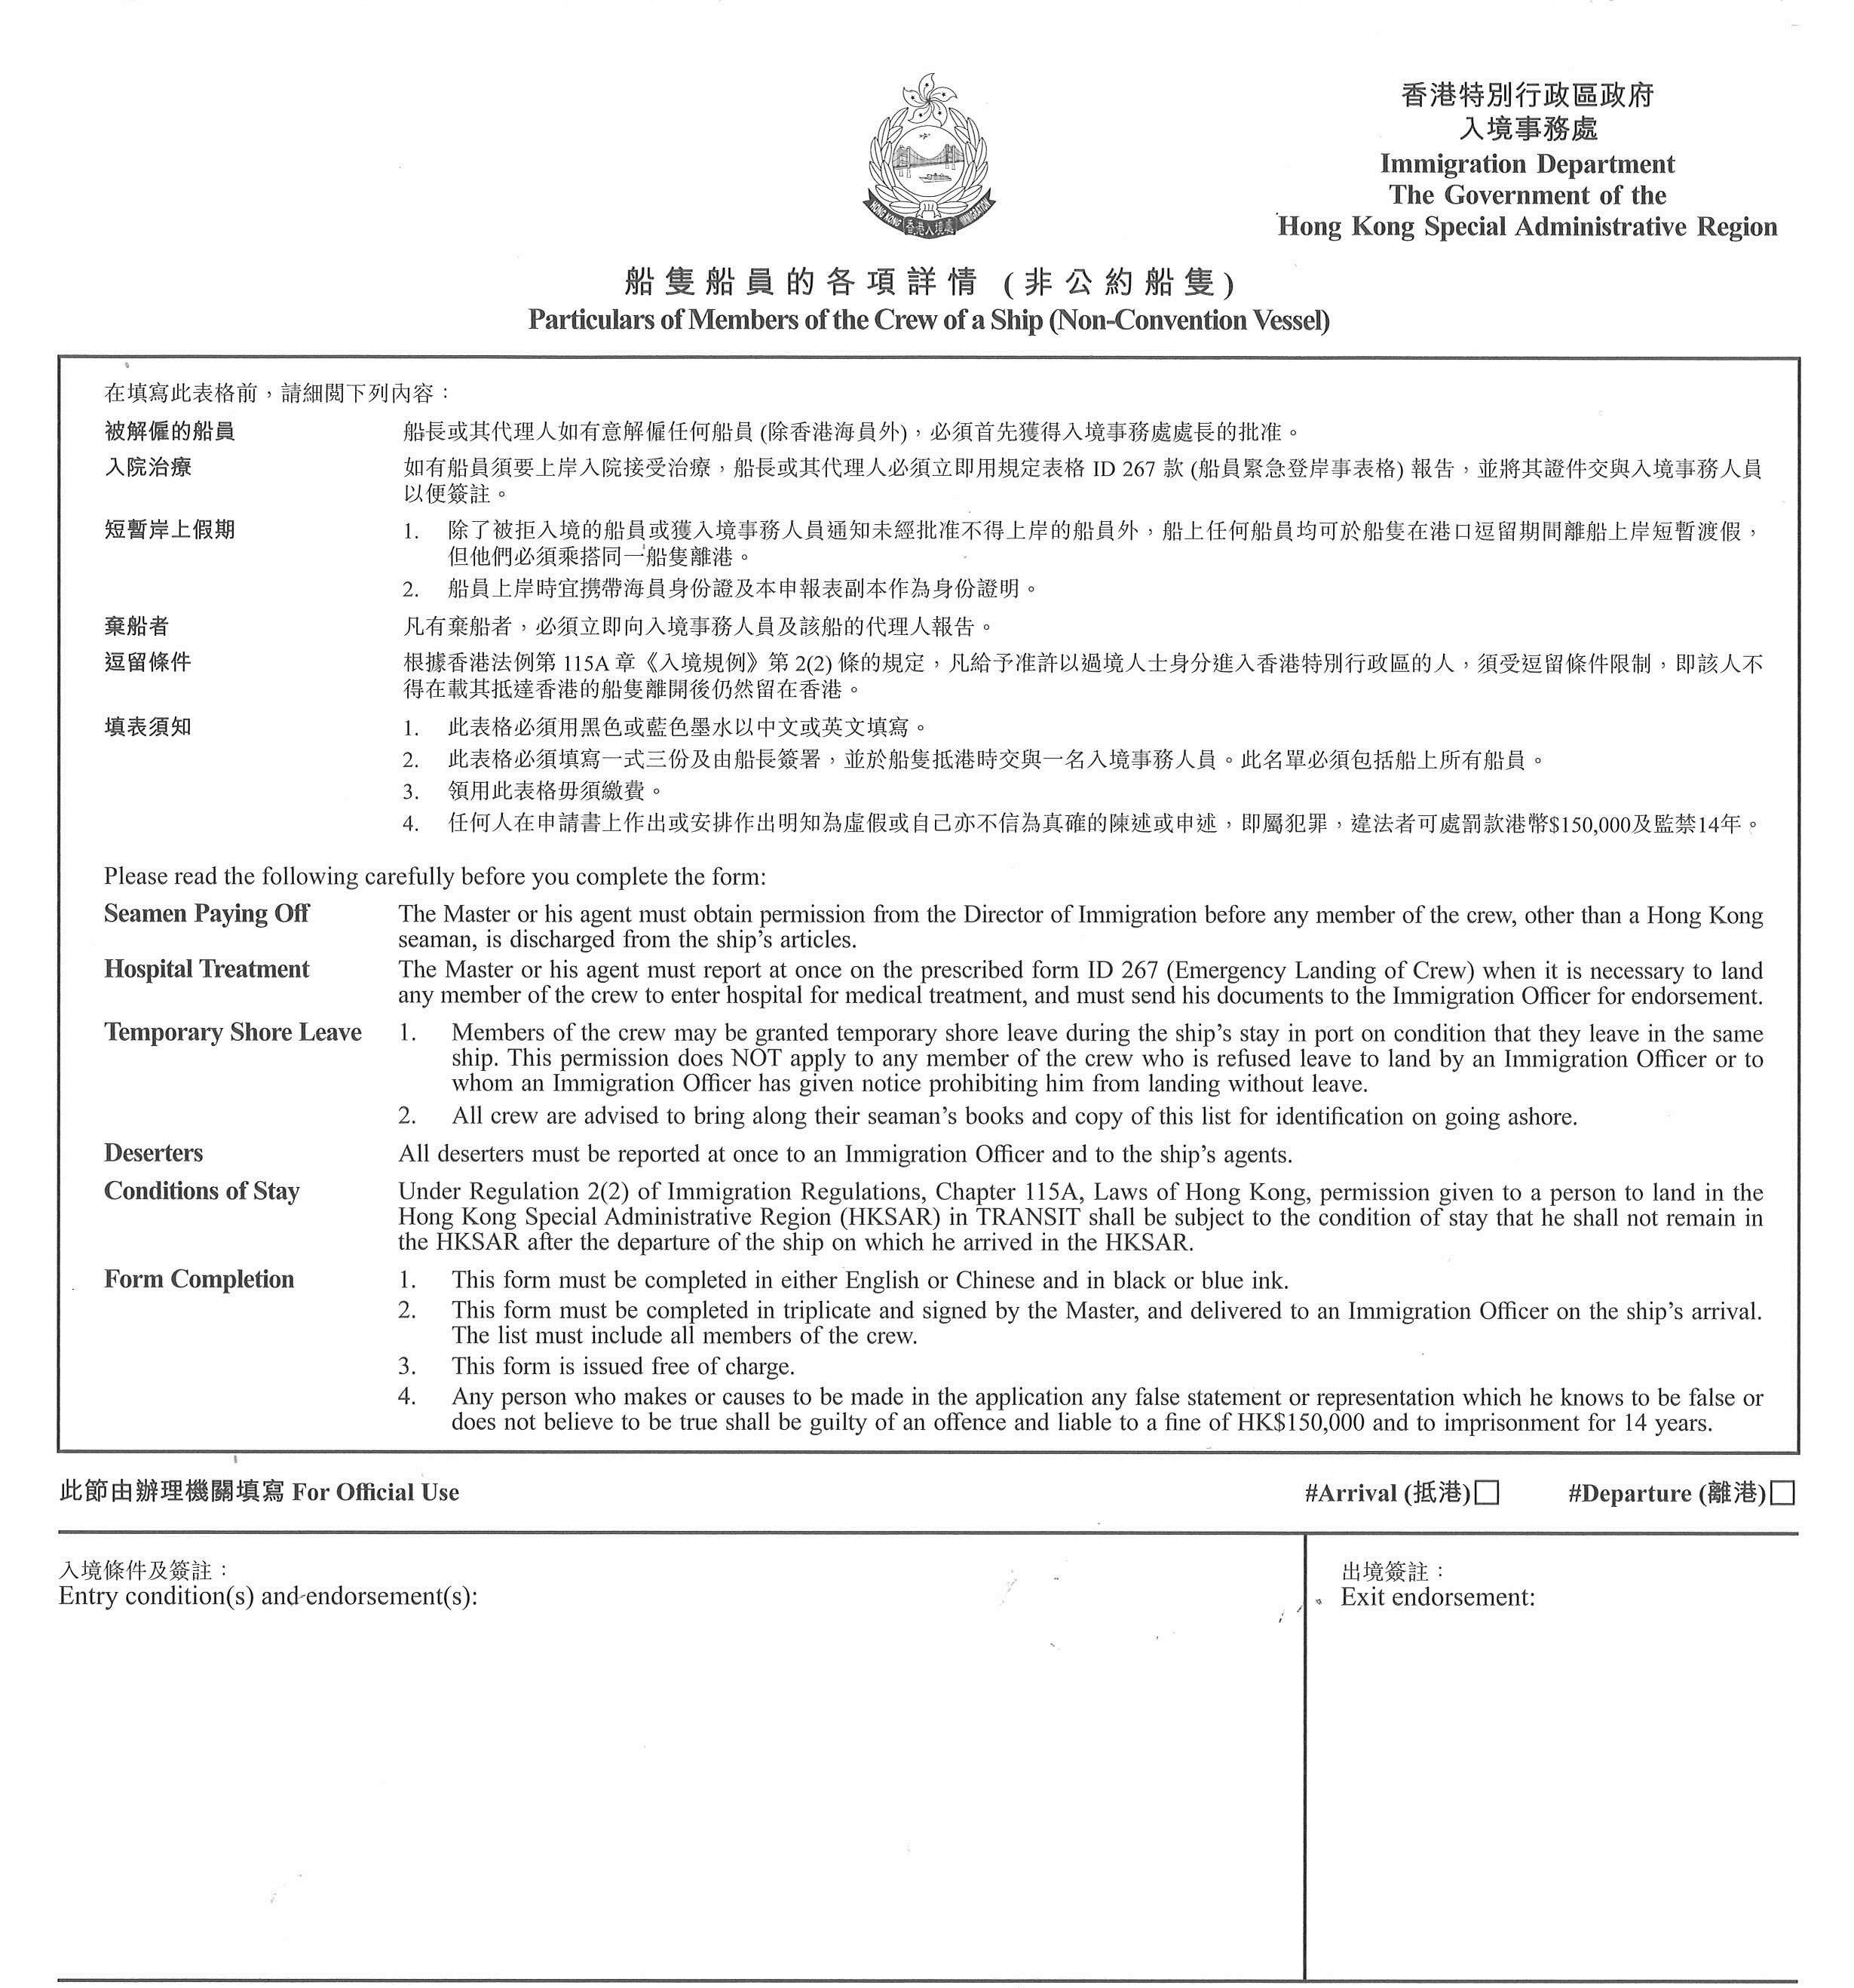
船隻名稱  Name of ship | 本港代理人  Local agents | 停泊處  Anchorage/berth
船隻國籍  Nationality of ship | 來自何埠  Arrived from | 抵港日期  Date of arrival
船主  Oweners | 將往何埠  Next port of call | 離港日期  Date of proposed departure
來港目的
Purpose of call Yacht Race
本人證明船上有 名乘客(乘客的定義是符合入境條例所規定)， 名船員及 名偷渡者。
I certify that there are on board _________ passengers as defined in the Immigration Ordinance, __________ crew and __________ stowaways.

日期 船長簽署
Date _____________________________ Signature of Master______________________________________
#請在合適的空格內√◦ #Please put a tick in the appropriate box.
( 接 下 頁 )
I.D. 207A (4/2022) To be continued
姓 (請用正楷填寫)  Surname  (in block letters) | 名 (請詳細列明)  Other names (in full) | 性別Sex | 職級Rating | 出生地點及日期  (請詳列年月日)  Place & date of birth  (in full) | 國籍Nationality | *海員身份證號碼  *Seaman’s Book number | 備註Remarks
9.
10.
11.
12.
13.
14.
15.
16.
17.
18.
19.
20.
21.
22.
23.
24.
25.
26.
27.
28.
29.
30.
*如屬香港海員,請在「備註」欄內填上身份證號碼。
For Hong Kong seaman, please state Hong Kong identity card number in the ‘Remarks’.

